**Recommended Lesson Plans**

**For Instructors**

**Manual J** – Residential Load Calculations

**Manual S** – Residential Equipment Selection

**Manual D** – Residential Duct Systems

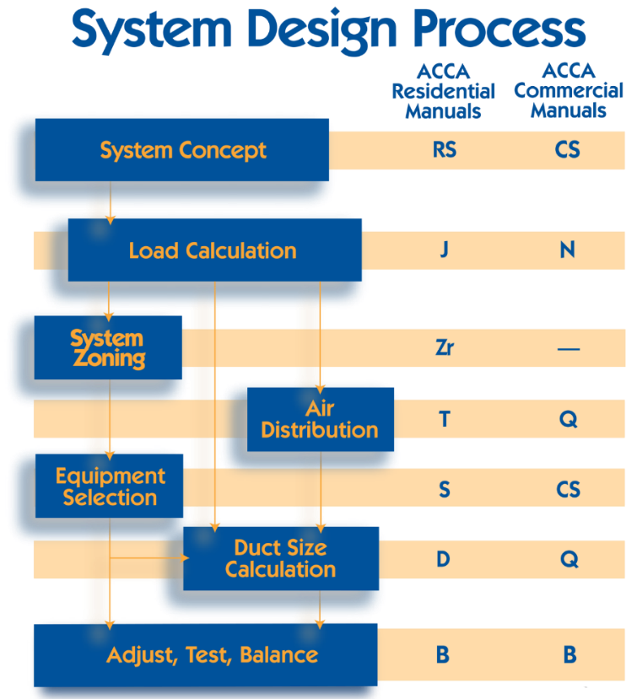

**18 August 2015**

Recommended Lesson Plans for ACCA Design Manuals

The lesson plans included in this document are intended for use by HVAC instructors at vocational schools and community colleges as a method of introducing their students to industry-accepted procedures for HVAC system design described in the code-cited ACCA design manuals. It presents three modules that cover the three major steps of the system design process; i.e., conducting a heating and cooling load calculation, sizing and selecting the proper equipment, and sizing of the ductwork in the air distribution system. (The other major steps in HVAC design are: zoning, air grille selection, and testing and balancing.) The three modules are each split into three classes (lesson plans) that address the principles and methods for the respective module. The outline format allows the instructor to expand or contract the actual lesson to suit the needs of their students, available materials, or pre-existing course requirements.

At the end of the three lessons, a student will be able to:

1. Conduct an accurate MJ8ae block load calculation using the free ACCA speed-sheet,
2. Use OEM expanded performance data to select equipment that will meet the home’s load requirements,
3. Size the ducts in the distribution system to ensure that the proper amount of air reaches each room.

Included with each lesson plan is an associated pre-class reading and a homework assignment. The pre-class reading is intended to prepare the student for the content of the day’s lesson, while the homework assignments require an active search for the correct answer (and may require investigation of the textbook on subjects that were not covered in class). ACCA recommends that the instructor conclude the HVAC design portion of their course with a design problem that encompasses the three major design steps.

**Load Calculations**

**Day 1 – Load Calculations Basics** (90 minutes)

Pre-class reading: Heating and cooling loads – curriculum p.6

Class content:

* Load calculation is the sum of all heating or cooling loads
  + Examples of loads found in a typical home
* Design conditions
  + Winter: outdoor design temperature (heating 99%) and indoor design temperature (70°F)
  + Summer: outdoor design temperature (cooling 1%) and indoor design temperature (75°F)
* Basic load equation: *load = U x A x ΔT*
  + U is the heat transfer performance index (how well a material transfers heat; reciprocal of r-value)
  + A is the area
  + ΔT is the temperature difference
  + Simplification: *load = HTM x A* where HTM = U x ΔT
* Designer options:
  + Simple load calculation (MJ8ae)
  + Full load calculation (full MJ8)

Homework: Questions on MJ8 Section 2 and Glossary definitions – curriculum p.7

**Day 2 – Manual J8ae Tables** (90 minutes)

Pre-class reading: MJ8ae applicability – curriculum p.8

Class content:

* Review of abbreviations used in MJ8ae terminology
  + HTM, SHGC, CLTD, HTD
* Introduction to content:
* Table 1A: Weather Data for USA
* Table 2A and 2B-4: U-values and SHGC for Generic Fenestration
* Table 3A and 3C: Default Cooling HTM Values for Generic Fenestration
* Table 4A: Opaque Panel U-values, CLTDs and Group Numbers
* Table 4B: Wall CLTDs
* Table 4C: Approximate Temperature in Unconditioned Spaces
* Table 5A: Infiltration ACH Values
* Table 6A: Internal Loads
* Table 7: Duct Loss and Duct Gain Factors
* Table 8A: Procedure for Evaluating Ventilation Requirement
* Table 10A: Altitude Correction Factors for Sensible and Latent Heat Equations
* Table 11: Blower Motor Heat

Homework: Exercises on reading tables to find specific values given sample conditions – curriculum p.9

**Day 3 – Using ACCA MJ8 Speed-sheet** (90 minutes)

Pre-class reading: MJ8ae capabilities and sensitivities – curriculum p.10

Class content:

* Watch explanatory video on using Manual J speed-sheet (<http://www.acca.org/standards/acca-speed-sheets/>)
* Simple sample problem done in class, with student participation for each step

Homework: MJ8ae speed-sheet load calculation – curriculum p.13

**In securing a better understanding of the material or for the creation of a lesson plan, ACCA offers the following additional resources for instructors:**

* HVAC Essentials: Understanding Manual J
* Residential HVAC Design for Quality Installation (online, in-person, host classes)
* ACCA introduction on mechanical system design for code officials – Manual J module

Day 1 Pre-Reading: Heating and Cooling Loads

**Load calculation:** A systematic method of evaluation to estimate heat loss, sensible and latent heat gain; an account of the total heat flow into or out of a home (depending on the time of year).

We need to do load calculations in order choose equipment that will make an occupant comfortable and safe, and to keep energy costs down. During the load calculation, the designer has to account for every source of heat gain or heat loss; these gains or losses are what we call loads. The units for a load: BTU/hr.

Winter heat loss:

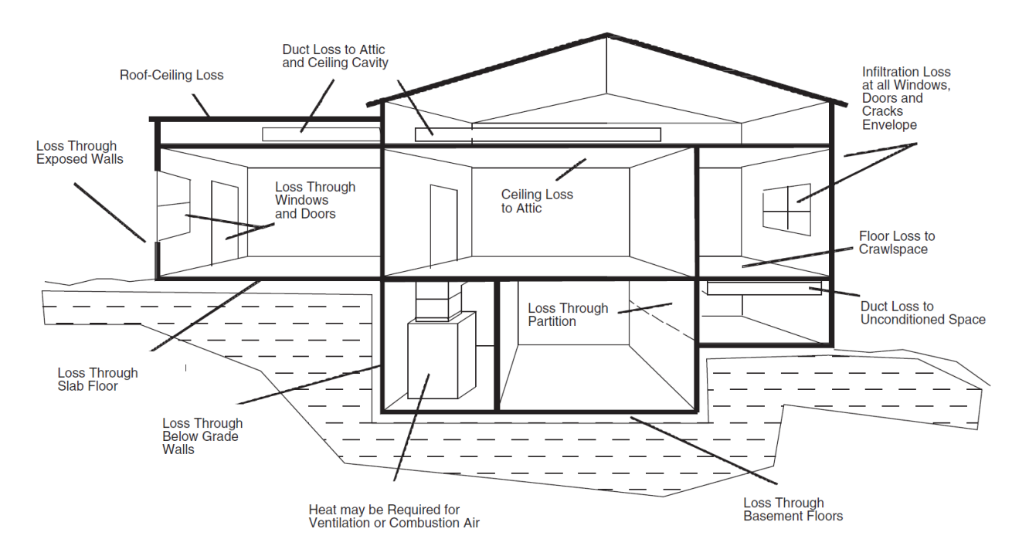

Figure 1-2 from Manual J8ae – 2011 is reprinted with permission from ACCA

Summer heat gain:

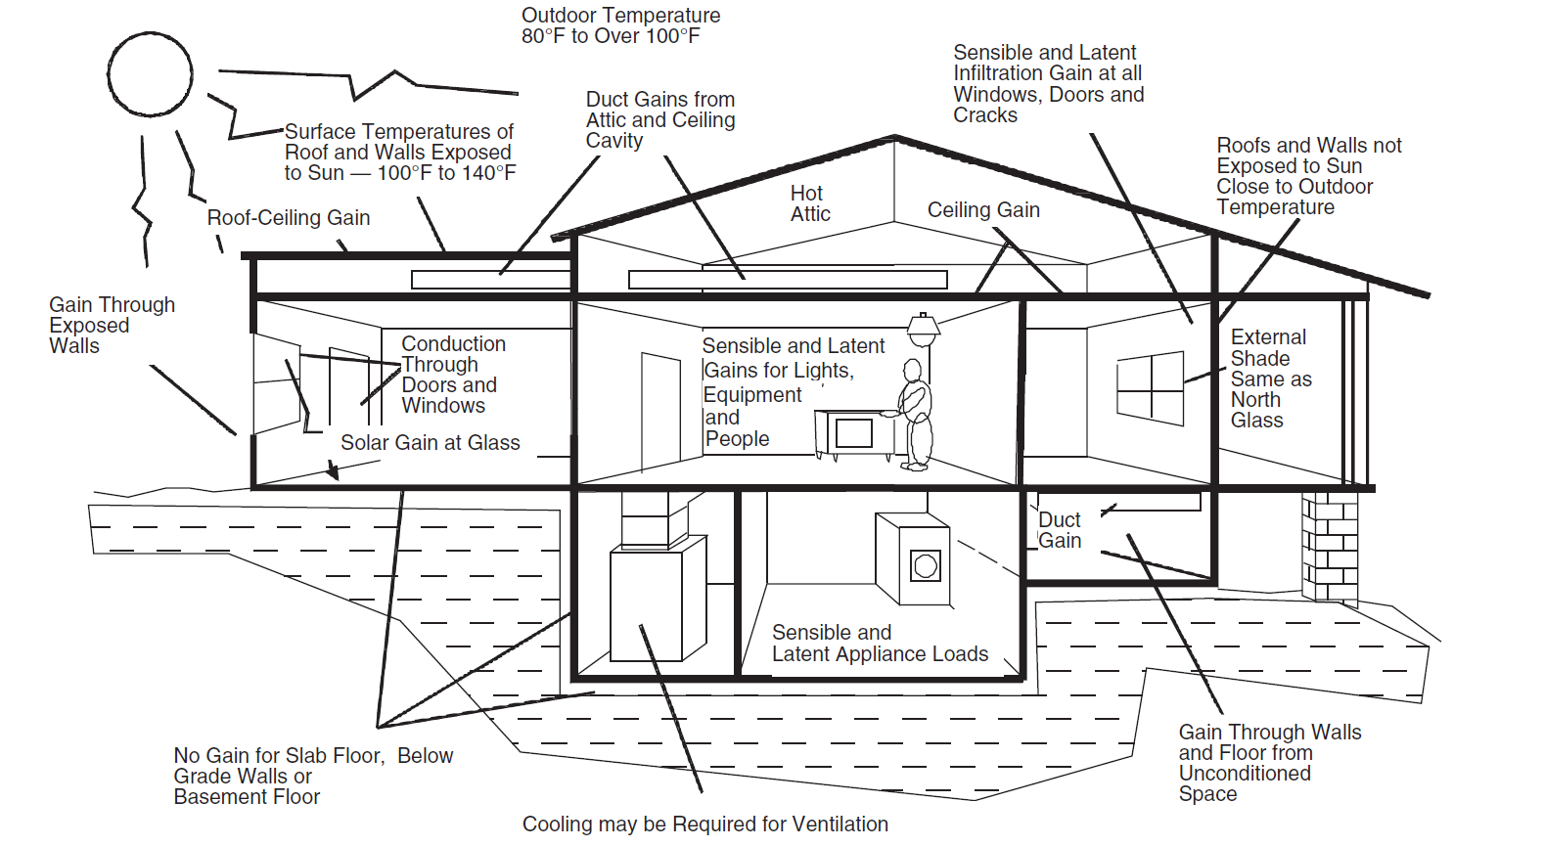

Figure 1-3 from Manual J8ae – 2011 is reprinted with permission from ACCA

Day 1 Homework: Do’s, Don’ts, Definitions

Insect screens found at the house will affect the load calculation. T F

There is no reason to design for abnormally low indoor temperatures. T F

Manual J’s outdoor design conditions (weather data) can be superseded by local code requirements. T F

Outdoor design conditions in summer should be based on the previous year’s highest temperature. T F

Kitchen exhaust fans are not part of the ventilation system. T F

Multiplying the final, calculated cooling load by a safety factor is not acceptable. T F

Multiplying the final, calculated heating load by a safety factor, however, is acceptable. T F

Selecting the proper equipment to match the load requirements is covered in ACCA Manual D. T F

Add more than 1 person per room to the occupancy load for frequent entertainment. T F

Define the following:

1. Thermal Envelope
2. CLTD
3. 1% Summer Outdoor Drybulb
4. Latent Heat
5. Design Temperature
6. Sensible Heat
7. CFM
8. System Load
9. Zone
10. 99% Winter Outdoor Drybulb
11. Infiltration
12. Fenestration
13. U-value

Day 2 Pre-Reading

ACCA Manual J8 Abridged Edition (MJ8AE) is sufficient for learning the Manual J procedures and for making hand calculations for various types of homes. The advanced procedures of the unabridged version of Manual J shall be used for homes that have significant performance upgrades / modifications, and for homes that have notable features (i.e., large glass areas, multi-zone systems, NFRC labeled glass, blower door test, heat recovery systems, radiant barrier, large internal loads, sun rooms, atriums, etc.).

MJ8AE is the abridged version of the Eighth Edition of Manual J. The structure of both publications is identical.

An example home for which MJ8AE is applicable would have the following attributes:

* Single family detached home;
* Single-zone, constant volume HVAC system;
* Windows and / or glass doors on all sides of the home;
* Flat, clear glass skylights, if any;
* Dark shingle roof

Day 2 Homework: Reading MJ8ae Tables

Review the following Manual J8ae Tables and their notes:

Table 1A – Outdoor Design Conditions for the United States

Table 2A – Default Performance Values for Generic Fenestration

Table 2B-4 – Skylight Curb Size

Table 3A – Default Cooling HTM for Generic Windows and Glass Doors

Table 3C – Default Cooling HTM for Generic Skylights

Table 3E – HTM Adjustment for Shade by Overhang

Table 4A – Heating and Cooling Performance for Opaque Panels

Table 4B – Wall CLTD

Table 4C – Approximate Ambient Temperature in a Closed Garage

Table 4D – Approximate Ambient Temperature in an Isolated Sunroom

Table 4E – Approximate Ambient Temperature in an Encapsulated Attic

Table 5A – Infiltration Air Change Values for Three or Four Exposures

Table 6A – Default Scenarios and Values for Internal Loads

Table 7 (AE) – Duct Load Tables

Table 8A – Default Ventilation Rate

Table 10A – Altitude Correction Factors for Sensible and Latent Heat Equations

Table 11 – Blower Motor Power

Find the following values:

1. 1% summer outdoor drybulb for Sterling, VA
2. 99% winter outdoor drybulb for Ashville, NC
3. Design grains 50% RH for Cheyen, WY
4. 1% summer outdoor drybulb for Muncie, IN
5. 99% winter outdoor drybulb for Tofte, MN
6. Design grains 50% RH for Albany, NY
7. 1% summer outdoor drybulb for Lancaster, PA
8. 99% winter outdoor drybulb for Providence, RI
9. U value for a double-pane operable window with a metal frame with break
10. U value for a French door with single-pane clear glass with an insulated fiberglass frame
11. HTM for a flat clear glass skylight, triple pane, glazing panel inclination 30 degrees from horizontal, design CTD 25, with a South East exposure
12. U value for a ceiling under an attic with R-21 insulation (also, what is the roofing material?)
13. Air changes per hour – cooling with a semi-tight construction, and 2800 sqft of floor area
14. Appliance load for a refrigerator and range with vented hood

Day 3 Pre-Reading: MJ8AE Capabilities and Sensitivities

Adapted from Appendix 2 of Manual J8ae – 2011 with permission from ACCA

MJ8ae is an abridged version of the Eighth Edition of Manual J. It provides an introduction to residential heat-loss and heat gain procedures. Mastery of the material MJ8ae is a prerequisite for using the unabridged version of Manual J. Mastery of this material is a prerequisite for using software products that perform Manual J calculations. MJ8ae assumes the practitioner is acquainted (or will become familiar with) with the basic mathematical calculations and heat transfer; and is conversant with Manual S, Manual D and Manual T design procedures.

**Limitations and Guidelines**

System design plays an important role in the comfort, health and safety of the occupants. MJ8AE may be used to estimate heat loss and heat gain for residential applications that have the following attributes.

* Cooling is provided by a central, single-zone, constant volume system (MJ8ae shall not be used for zoned systems).
* Single family detached dwellings shall have a normal amount of fenestration (total area of windows, glass doors and skylights shall not be more than 15 percent of the floor area).
* Windows and glass doors shall be equitably distributed around all sides of the dwelling.
* There shall be no large skylights in any room (skylight load area does not exceed 5% of floor area).
* The dwelling shall have adequate exposure diversity (see MJ8ae Appendix 3).
* There shall be no excursion adjustment for the sensible gain produced by the fenestration (see MJ8ae Appendix 3).
* Windows and glass doors shall have clear glass; skylights shall have a clear glazing.
* The dwelling shall have wood-frame or block (concrete or cinder) walls with brick, stucco or siding.
* The dwelling shall have a dark shingle roof.
* Attics shall be vented to FHA standards and shall have no radiant barrier.
* Envelope leakage shall be estimated by the Table 5A air-change method (see MJ8ae, Section 3-10).
* Simple default values for the appliance load shall be used to estimate internal gains.
* A duct system shall be entirely in the conditioned space, or shall be compatible with one of the system scenarios summarized by Figure 1-1 of MJ8ae Section 1.
* Duct run leakage shall be equal to the default values (for sealed ducts and unsealed ducts), unless verified by a field leakage test (see MJ8ae, Section 3-12).
* Engineered ventilation can be provided by piping a small amount (50 CFM or less) of fresh air to the return-side of the duct system (see MJ8ae, Section 3-13).
* Heating shall be provided by a hot air system or electric baseboard heat.

**Procedural Defaults**

Procedural complexity increases in proportion to sensitivity to variations in construction detail. Defaults simplify the procedure and make hand calculations possible. The defaults that apply to MJ8AE are listed here.

**Design Conditions**

* Indoor: Heating = 70 F; Cooling = 75 db F and 50% RH, unless superceded by code.
* Outdoor: Use values in Table 1A of this guide, unless superceded by code.

**Windows and Glass Doors**

* Window and glass doors shall have clear (single, double or triple pane) glass.
* Window and glass door framing shall be metal, metal with break, wood or vinyl.
* Windows can have fixed or operable sash (sliding glass doors have an operable sash).
* Purpose-built daylight windows and skylights shall have no internal shade.
* All other windows and glass doors shall have internal shade.
* The default assumption for internal shade is a medium-color blind with the slats at 45 degrees.
* Windows and glass doors shall not be equipped with external sunscreens.
* An overhang adjustment shall be applied to all windows and glass doors.
* When the information is available, use the actual overhang geometry or use the default geometry.
* The default length of the overhang is one foot; the default height above the glazing is one foot.
* The heat-gain adjustment for any type of bug screen shall be 0.90.
* The heat loss and gain adjustment for a bay window shall be 1.15.
* The heat loss adjustments for a garden window shall be 2.75 and the heat gain adjustment shall be 2.00.
* The heat gain adjustment for a French door shall be 0.70.
* The foreground reflectance for window and glass door heat-gain shall be 0.20.

**Skylights**

* Skylight glazing shall be flat.
* Skylights shall have clear (single pane or double pane) glass.
* Curb construction shall default to (un-insulated) wood 2x4; four inches high.
* Skylights shall not be equipped with an internal shade.
* Skylights shall not be equipped with a light shaft

**Wood and Metal Doors**

* Door glass area shall be ignored if the door glass area is less than or equal to 50% of the total door area.
* The French door option shall apply if the door glass area is more than 50% of the total door area.

**Walls**

* Above grade wall construction shall be wood-stud frame or empty-core block.
* Exterior finish options shall be brick veneer or stucco/siding.
* Interior finish shall default to gypsum board (i.e. plaster board, dry-wall, sheet rock, etc.)
* Below grade wall construction shall default to empty-core block.
* Block walls may have board insulation and/or wood-stud framing with blanket or fill insulation.

**Ceilings and Attic Knee Walls**

* The ceiling options shall be: Attic ceiling, ceiling on exposed beams or joist-ceiling sandwich.
* The roofing material shall be dark-shingles.
* The roof deck material shall default to plywood for all types of roof construction.
* Attic construction shall default to FHA-vented with no radiant barrier.
* Knee walls shall be installed in a FHA-vented attic space.
* Insulation shall be blanket and/or board or fill (as appropriate for the type of roof construction).

**Floors**

* All floors shall be passive (no heating elements below the floor).
* Floors over an open space shall have carpet or tile cover with floor insulation options.
* Slab floors shall have vertical insulation that covers the edge, or no insulation.
* Slab floor soil conditions shall be heavy-moist; heavy-dry; light-wet; or light-dry.
* Basement floors shall be un-insulated.
* Floors over a closed space shall default to no wall insulation (for closed space), with floor insulation options.
* Floors over a closed space shall default to construction 19A (Table 4A, MJ8).

**Infiltration**

* All infiltration estimates shall be based on the ACH values provided by Table 5A of this guide.
* Dwellings shall be rated: very-tight, semi-tight, average, semi-loose and loose (definitions are provided).
* There shall be no space pressure adjustment for engineered ventilation that affects space pressure
* Infiltration induced or reduced by duct runs in an unconditioned space is evaluated by the duct-table factors.

**Internal Gains**

* The number occupants shall equal the number of bedrooms plus one.
* The internal appliance-gain options are 1,200 BTU/h or 2,400 BTU/h.
* The latent gain produced by plants shall be evaluated

**Duct Systems**

* All duct runs shall be in the conditioned space, or shall conform to one of the Table 7 scenarios.
* Duct runs (trunks and runouts) shall be (essentially) installed in one horizontal plane.
* Leakage rates for sealed ducts shall default to 0.12 (supply-side) and 0.24 (return-side) CFM per Ft2 unless a tighter rating is justified by a duct leakage test.
* The supply air temperature for heating shall default to 100oF (worst case for the heating load factor).

**Engineered Ventilation**

* Engineered ventilation is mandatory when required by code (the ventilation rate also may be determined by code).
* Table 8 shall be used to evaluate the fresh air requirement (ventilation rate) when there is no code requirement.
* Table 8 offers guidance with no expressed or implied guarantee or warrantee; compliance is not mandatory.
* The system designer shall evaluate (by tests specified in codes and standards) the potential for pressure conditions that could cause combustion appliance back-drafting.
* If the designer elects to provide engineered ventilation, fresh air shall be provided by piping outdoor air to the return-side of the duct system (refer to the unabridged version of Manual J if the flow rate of outdoor air exceeds 50 CFM).

**Blower Heat**

* A blower heat adjustment shall be made when manufacturer’s performance data is not discounted for blower heat.
* The blower heat adjustment shall be 500 Watts (1,707 BTU/h).

**Limitation**

The principles and procedures presented in this guide apply to any dwelling that is 100 percent compatible with preceding list of limitations, guidelines and defaults. The unabridged version of Manual J shall be used for any and all dwellings that are not compatible with the above list.

**Application**

A heat loss and heat gain estimate is the mandatory first-step in the system design process. This information is used to select heating and cooling equipment. This information and the information provided by equipment manufacturer performance data is used to determine system airflow rate and room airflow rates, supply outlet and return grille sizes and duct sizes (per Manual S, D and T protocols).

**Comfort and Air Quality**

Incorrect system design procedures (or installation, commissioning, maintenance and operating practices) may cause comfort and air quality problems. Individuals and organizations not familiar with Manual J, Manual S and Manual D procedures tend to assume the problem is caused by equipment that is too small. This is normally not the case. See Appendix 7 (Trouble Shooting) for more information on this subject.

**Hand Calculations**

The tables and equations in this guide are a subset of the tables and equations provided by the unabridged edition of Manual J. This simplification produces a procedure that can be performed without the aid of a computer. A computer is strongly recommended for full, unrestricted applications of Manual J (refer to www.acca.org/standards/approved-software for recommended third-party software recognized by ACCA).

Day 3 Homework: MJ8ae Speedsheet Load Calculation

Perform a block load calculation for the following home:

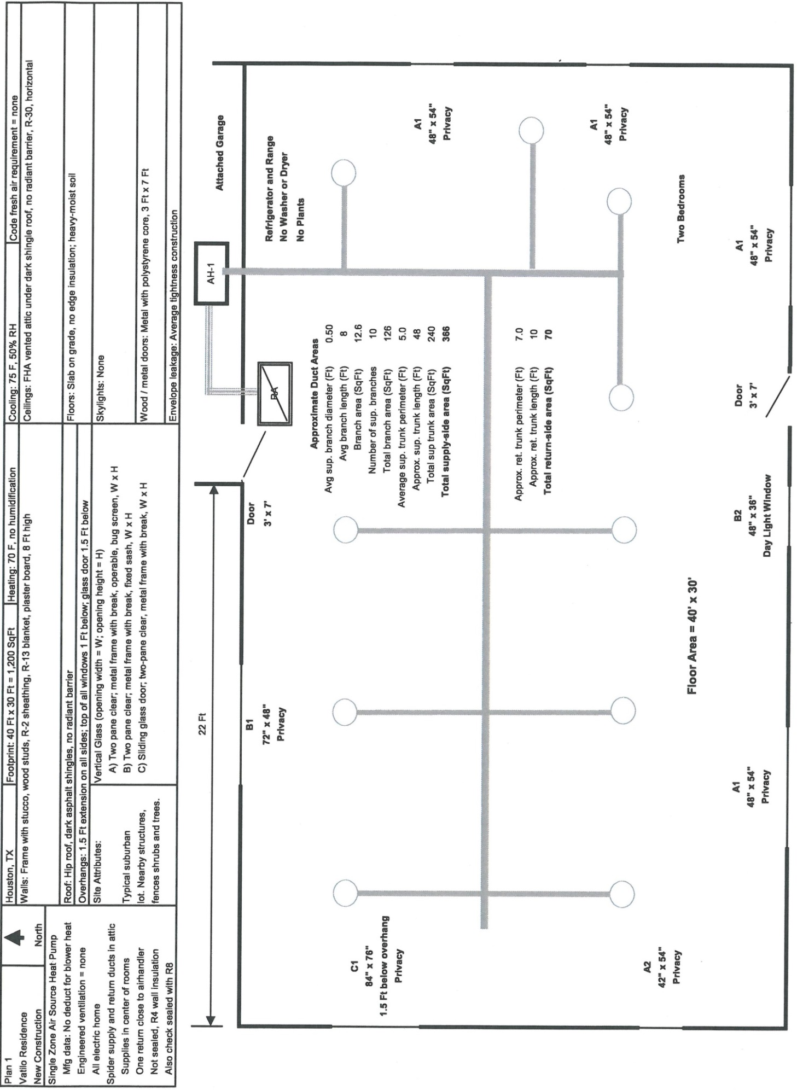

Figure 7-3 from Manual J8ae – 2011 is reprinted with permission from ACCA

**Equipment Selection**

**Day 1 – Equipment Selection Basics** (90 minutes)

Pre-class reading: Equipment selection overview – curriculum p.15

Class content:

* Section N1-3 equipment selection and sizing procedure
  + Produce a load calculation
  + Determine heat pump sizing condition (as applicable)
  + Procure OEM performance data
  + Determine blower Cfm values for cooling/heating
  + Evaluate entering air condition
  + Extract capacity values from OEM performance data
  + Select equipment that conforms with sizing limit
* Heat pump sizing conditions
  + Condition A vs. Condition B
  + HDD/CDD proxy
* Performance data examples
* Altitude corrections
* Sizing limit tables
* Excess latent capacity

Homework: Questions on Manual S Sections N1, N2 and definitions– curriculum p.17

**Day 2 – Capacity Values From OEM Performance Data** (90 minutes)

Pre-class reading: Interpolation – curriculum p.18

Class content:

* Sample OEM performance data
  + Examples of various table formats
* Interpolation example problems
* Comparison of capacity values to sizing limits

Homework: OEM expanded performance data and interpolation – curriculum p.19

**Day 3 – Comprehensive Examples** (90 minutes)

Pre-class reading: Consequences of oversizing – curriculum p.20

Class content:

* Practice problems covering: condition, interpolation, sizing limits

Homework: Equipment search and capacity values – curriculum p.21

Day 1 Pre-Reading: Equipment Selection Overview

The major steps to equipment selection are as follows:

1. The designer will begin with the sizing values from the load calculation. For cooling-only or cooling-and-heating applications, this is the total cooling load (sensible and latent); for heating-only applications, the sizing value is the total heating load.
2. The designer will then use the Original Equipment Manufacturer (OEM) performance data to find out what the equipment’s actual capacity is for the operating conditions. This will generally not be the rated capacity, and the designer will usually need to extrapolate the values from the OEM’s tables. To do this they will need to determine the entering air condition and the blower Cfm values for cooling and heating.
3. Next they will look at the sizing rules for the type of equipment they want to install. ACCA’s Manual S provides an acceptable range (i.e., upper limit and lower limit) for the equipment’s total capacity that’s based on the sizing value from the first step.
   1. If the equipment to be installed is a heat pump, then Manual S allows for an alternative acceptable range for situations when humidity control is not an issue; this is called Condition B sizing.
   2. Half of the excess latent capacity can be added to the sensible capacity.

The types of equipment covered by Manual S are the following:

* AHRI-certified cooling-only equipment (single-, two-, and variable-speed compressor)
* AHRI-certified heat pump equipment (single-, two-, and variable-speed compressor)
* Electric heating cools
* Fossil fuel furnaces
* Water boilers
* Water heaters used for space heat
* Dual fuel systems
* Ancillary dehumidification
* Humidification
* AHAM appliances
* Direct evaporative cooling equipment

Example Manual S sizing limits table (cooling-only equipment):

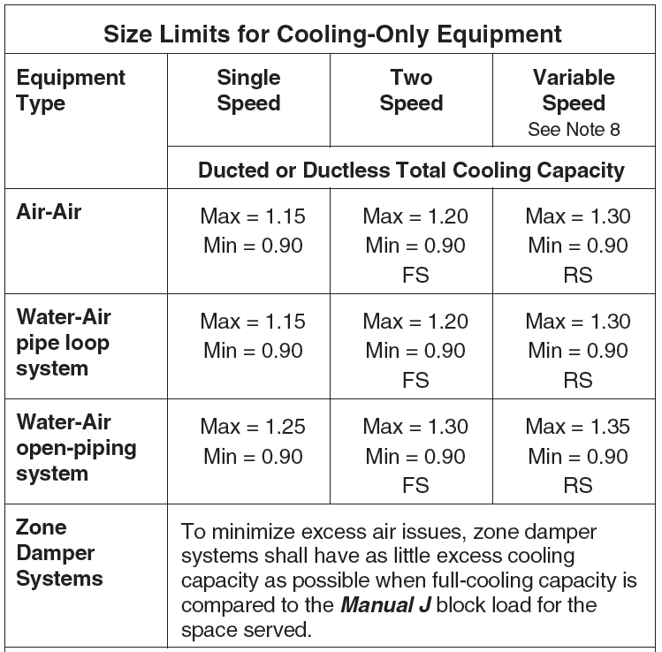 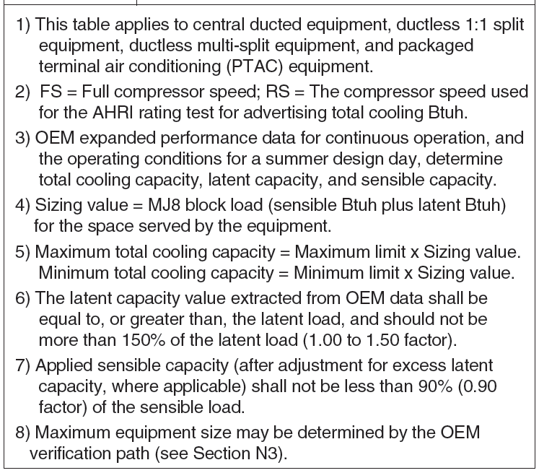

Day 1 Homework: Sections N1 and N2

Define the following:

1. AHRI Rating Speed
2. HDD-65
3. CDD-50
4. Thermal Balance Point
5. Applied Capacity
6. Full Capacity
7. Expanded Performance Data
8. Full Compressor Speed
9. Over-Size Limit
10. Over-Size Factor

What are the outdoor and entering air conditions for the Cooling-A test per ANSI/AHRI Standard 210/240?

What are the requirements for Heat Pump Sizing Condition A?

What are the requirements for Heat Pump Sizing Condition B?

Above what elevation must the designer adjust equipment performance data?

What is the maximum allowable total cooling capacity for a single-speed heat pump in Condition B?

What is the maximum allowable total cooling capacity for a two-speed heat pump in Condition A?

What is the maximum output capacity for a heating and cooling fossil fuel furnace?

What is the maximum allowable total cooling capacity for a variable-speed heat pump in Condition B?

What is the maximum allowable total cooling capacity for a two-speed air conditioner?

What is the maximum output capacity for a heating-only fossil fuel furnace?

Day 2 Pre-Reading: Interpolation

OEMs present their expanded performance data in various ways, which range from printed data tables to software that only requires the input of the operating conditions to produce the equipment’s capacity. If a designer only has printed tables available to them, it is likely that they will need to interpolate from the values shown on the table.

Below is a typical table that shows the air resistance across a coil for different models of equipment. You can see that for a given air volume (CFM) there are associated dry coil and wet coil pressure drops (inches water gauge).

|  |  |  |  |
| --- | --- | --- | --- |
| **Air Resistance Across The Coil** | | | |
| **Model**  **Number** | Air Volume  CFM | Dry Coil  in. w.g. | Wet Coil  in. w.g. |
| **XYZ** | 200 | 0.03 | 0.04 |
| 400 | 0.08 | 0.09 |
| 600 | 0.14 | 0.17 |
| 800 | 0.22 | 0.29 |
| 1000 | 0.31 | 0.42 |

From the table, we can see that for this model (XYZ), if the air volume across the wet coil is 600 CFM, then there will be a pressure drop of 0.17 in. w.g. If the air volume is 1000 CFM, the pressure drop across a dry coil will be 0.31 in. w.g. **But what is the pressure drop over a dry coil if the air volume is 500 CFM?** As you can see, the table only shows values for 400 and 600 CFM. Therefore we’ll need to interpolate from the values that air present.

Step 1: Total CFM Difference: 600 – 400 = 200 CFM. This is the difference between the two closes values shown on the table.

Step 2: CFM Ratio Factor: 600 – 500 = 100 CFM. This is the difference between the upper table value (600 CFM) and the value we’re interpolating for (500 CFM)

Step 3: CFM Ratio = CFM Ratio Factor / Total CFM Difference = 100 / 200 = 0.5. These values come from the first two steps.

Step 4: Total Pressure Difference = 0.14 – 0.08 = 0.06 in. w.g. These values correspond to the upper table value (600 CFM, 0.14 in. w.g.) and lower table value (400 CFM, 0.08 in. w.g.).

Step 5: CFM Ratio *x* Total Pressure Difference = 0.5 *x* 0.06 = 0.03 in. w.g.

Step 6: Subtract from the upper pressure value = 0.14 – 0.03 = **0.11 in. w.g.** pressure drop across a dry coil when the air volume is 500 CFM

Follow the same method for determining the **pressure drop for a wet coil when the air volume is 460 CFM**.

Step 1: Total CFM Difference: 600 – 400 = 200 CFM.

Step 2: CFM Ratio Factor: 600 – 460 = 140 CFM.

Step 3: CFM Ratio = CFM Ratio Factor / Total CFM Difference = 140 / 200 = 0.7.

Step 4: Total Pressure Difference 0.17 - 0.09 = 0.08 in. w.g.

Step 5: CFM Ratio *x* Total Pressure Difference = 0.7 *x* 0.09 = 0.063 in. w.g.

Step 6: Final answer: 0.17 – 0.063 = 0.107 in. w.g.

Day 2 Homework: OEM Expanded Performance Data and Interpolation

|  |  |  |  |  |  |  |  |  |
| --- | --- | --- | --- | --- | --- | --- | --- | --- |
| ABC Company FU60-036 | | | | | | | | |
| Air Delivery – CFM (with filter) | | | | | | | | |
| Unit Size | Speed | External Static Pressure (inches water column) | | | | | | |
| 0.1 | 0.2 | 0.3 | 0.4 | 0.5 | 0.6 | 0.7 |
| FU60-024 | High | 1075 | 1040 | 995 | 945 | 895 | 840 | 760 |
| Med-Hi | 950 | 925 | 895 | 845 | 795 | 740 | 660 |
| Med-Lo | 850 | 825 | 780 | 740 | 685 | 635 | 560 |
| Low | 740 | 700 | 650 | 620 | 565 | 515 | 455 |
| FU60-036 | High | 1470 | 1415 | 1400 | 1285 | 1215 | 1120 | 995 |
| Med-Hi | 1315 | 1280 | 1235 | 1198 | 1115 | 1035 | 930 |
| Med-Lo | 1125 | 1119 | 1085 | 1045 | 995 | 915 | 830 |
| Low | 930 | 925 | 910 | 850 | 830 | 770 | 705 |
| Note: Airflow based on a dry coil at 120v with factory approved filter. | | | | | | | | |

How many CFM can the FU60-036 blower deliver on the Med-Lo setting against a 0.4 iwc ESP?

What if the ESP is actually 0.46 iwc and the blower is on the Med-Hi setting?

Day 3 Pre-Reading: Consequences of Oversizing

There are various negative impacts of oversizing the HVAC equipment. They include the following:

Comfort Impacts

* Marginal part load temperature control
* Large temperature differences between rooms
* Degraded humidity control
* Drafts and noise
* Occupant discomfort/dissatisfaction

Health Impacts

* Increased potential for mold growth
* Potential to contribute to asthma and other respiratory conditions

Equipment Impacts

* Larger ducts installed
* Increased electrical circuit sizing
* Excessive part load operation
  + Frequent cycling
  + Shorter equipment life
* Nuisance service calls

Economic Impacts

* Higher installed costs
* Increased operating expense
* Increased installed load on the public utility system

Day 3 Homework: Equipment Search and Capacity Values

Can this be something along the line of, “find x piece of equipment on the AHRI directory. What is its actual capacity @ xyz conditions?

**Duct Sizing**

**Day 1 – Duct Sizing Basics** (90 minutes)

Pre-class reading: Duct sizing process overview – curriculum p.23

Class content:

* Process details
  + Pressure, operating point, pressure drop, friction rate, effective length, supply and return trunks, branches, TEL, component pressure drop, ASP, velocity limits, airflow calculations, blower Cfm and room Cfm, trunk Cfm values

Homework: Pressure drop, friction rate exercises – curriculum p.25

**Day 2 – Effective Lengths, Friction Rate, and Duct Wheels** (90 minutes)

Pre-class reading: Appendix 3 fitting equivalent lengths – curriculum p.26

Class content:

* Example problems for calculating system TEL
* Friction rate calculations
* How to use a duct wheel

Homework: Duct wheel problems – curriculum p.27

**Day 3 – Comprehensive Examples** (90 minutes)

Pre-class reading: Step-by-step problem worked out for PD, TEL, FR, Cfm – curriculum p.28

Class content:

* Sample problems (2)
  + Using duct wheel for sizing
  + Comparing with velocity limits

Homework: Sizing Table – curriculum p.31

Day 1 Pre-Reading: Duct Sizing Process Overview

Blowers move air through duct systems. The flow rate (cubic feet per minute, Cfm) delivered by a blower depends on the external resistance (pressure) the blower has to work against. Resistance is created when air is forced through a duct system; this resistance is caused by friction. If a blower is connected to a duct system, there is only one possible operating point. Since this point must be compatible with blower performance, it must fall on the blower curve. And since this point must be compatible with duct performance, it must fall on the system curve. This can only happen at the intersection of the two performance curves.

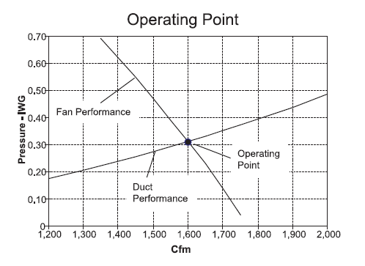

The basic objective of the Manual D procedure is to design a duct system that will work with the blower that is supplied with the HVAC equipment. To meet this objective, the airflow resistance produced by the duct system (duct runs, duct fittings, and air-side components), in terms of static pressure drop shall match the external static pressure (ESP) produced by the blower package (furnace or air handler) when the delivers the desired Cfm.

A pressure drop (PD) is the pressure loss between any two points in a duct system; units used are inches water column (IWC). A friction rate (FR) is the pressure drop between two points in a duct system that are separated by a specific distance; friction charts and duct slide rules use 100 feet for the reference distance, so before using a friction chart or duct slide rule to size a duct run, the system pressure drop value has to be converted to a friction rate value for 100 feet of duct (units IWC/100 ft.).

**FR = (PD *x* 100) / TEL**

Duct runs have straight section and fittings; and pressure losses are produced by these elements. Therefore, the total pressure drop for a duct run equals the pressure loss for all straight sections plus the pressure loss produced by each and every fitting in the duct run. The airflow resistance produced by a fitting is equivalent to feet of straight duct that produces the same airflow resistance. Fitting equivalent lengths are a convenient way to account for fitting pressure losses because fitting length values are simply added to the straight run lengths. The resulting total effective length (TEL) represents the total airflow resistance of the duct run.

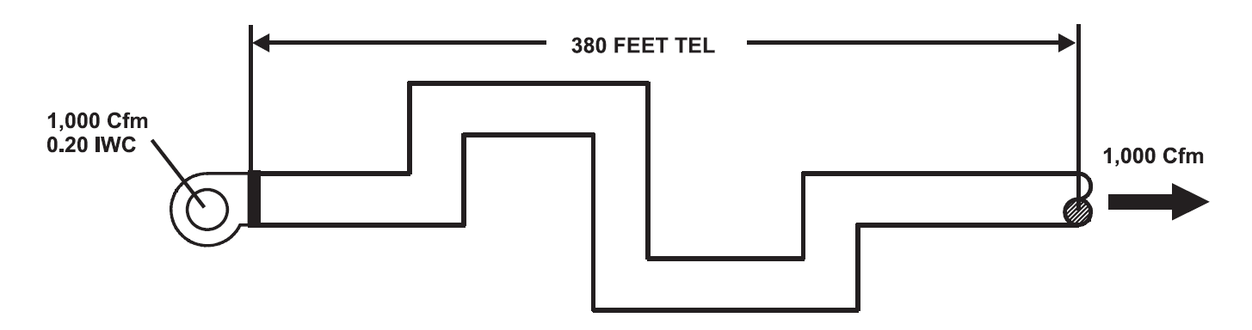

In the diagram above we see that the sum of all of the straight duct sections plus all of the fitting equivalent lengths totals 380 feet in TEL. We see also that the blower produces 1000 Cfm at a 0.20 IWC ESP. Plugging into the friction rate equation we have the following:

FR = (PD x 100) / TEL = (0.20 x 100) / 380 = 20 / 380 = 0.053 IWC/100

Using a duct slide rule, setting the friction rate to 0.053 IWC/100 and the flow rate to 1000 Cfm results in a round duct diameter of 16 inches.

Day 1 Homework: Pressure Drop and Friction Rate

1060 Cfm

0.50 IWC

S2

R2

S3

R1

S1

From the figure above, we know the following:

* R2 TEL: 125 ft
* R1 TEL: 65 ft
* S1 TEL: 55 ft
* S2 TEL: 230 ft
* S3 TEL: 450 ft

What is the system TEL?

What is the system FR?

Day 2 Pre-Reading: Equivalent Lengths

Manual D Appendix 3 contains default equivalent length values for various fittings, broken down into 14 different groups. The equivalent length values for supply-side fittings are for 900 Fpm air velocity and for 0.08 IWC/100 ft friction rate. The equivalent length values for return-side fittings are for 700 Fpm air velocity and for a 0.08 IWC/100 ft friction rate. The equivalent length values for fitting that are used on either side of the system are for 900 Fpm air velocity and for a 0.08 IWC/100 ft friction rate.

Equivalent length values are conditional; conditions that affect the aerodynamic performance of a fitting can include the geometry, the entering and leaving flow rate(s), or the entering and leaving velocities. Therefore, they should be accompanied by a note that lists the reference velocity (Vr), and the reference friction rate (FRr) that were used to generate the equivalent length information if not using the Appendix 3 default values.

The equation for calculating the equivalent length (ELx) for another velocity (Vx) or another friction rate (FRx) is the following:

ELx = EL x (Vx / Vr)2 x (FRr / FRx)

Equivalent length examples from Appendix 3:

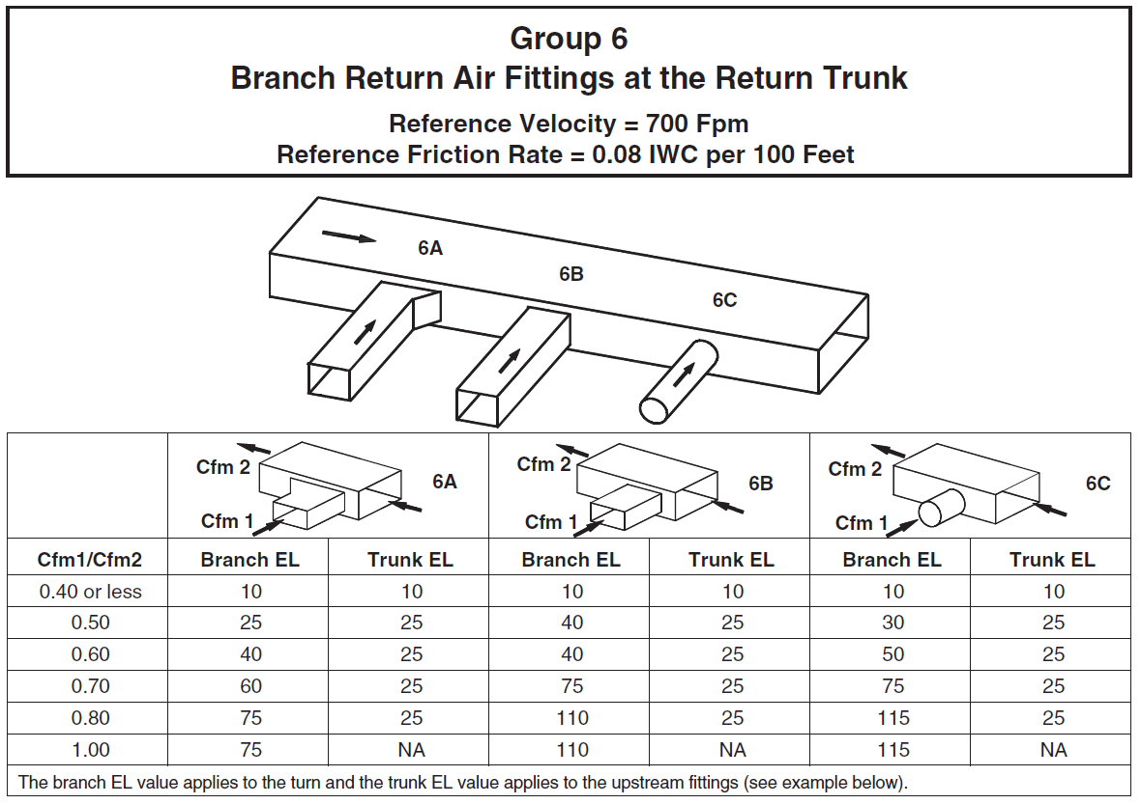

Day 2 Homework: Using A Duct Wheel

What is the round duct diameter for galvanized metal for the following combinations?

* Friction rate = 0.11 and volume = 1000 Cfm
* Friction rate = 0.10 and volume = 1400 Cfm
* Volume = 1000 Cfm and velocity = 850 fpm
* Volume = 1200 Cfm and velocity = 1200 fpm

Day 3 Pre-Reading: Example Problem

We have the following radial duct system:



(Supply Side)



(Return Side)

For the sake of simplicity, we can see that the fittings and boots used on the various supply and return runs are consistent (e.g.., all supply boots are 4J fittings from Appendix 3, so they’ll all have the same effective length). Because of this consistency, we can clearly see that the longest supply run is S7, and the longest return run is R3, because they both have the longest straight run lengths.

The effective length of S7 is computed as follows:

26 feet (runout length) + 35 (equivalent length of 1A fitting) + 30 (4J boot) + 20 (8A fitting) = 111 feet.

The effective length of R3 is computed as 10 (trunk) + 20 (runout) + 40 (5B) + 20 (6L) + 20 (8A) = 110 feet.

The blower table for this particular system is given in the following table:



From the table we see that, on the medium setting, the blower will deliver 800 Cfm against 0.36 IWC of ESP. For this system, the design calls for an electronic filter, a supply outlet, a return, and a hand damper. Note 2 in the blower table tells us that an electronic filter will result in 0.11 IWC component pressure loss. The supply outlet, return, and hand damper will each contribute 0.03 IWC in pressure loss. The total component pressure loss (CPL) will then be 0.20 IWC (= 0.11 + 0.03 + 0.03 + 0.03).

We now know the following:

* The blower deliver 800 Cfm at 0.36 ESP
* Total CPL is 0.20 IWC
* TEL for the longest duct run is 221 feet

Therefore, we can find this duct system’s Friction Rate (FR) with two simple calculations:

Available Static Pressure (ASP) = ESP – CPL = 0.36 – 0.20 = 0.16 IWC

FR = (ASP *x* 100) / TEL = (0.16 x 100) / 221 = 16 / 221 = **0.07 IWC/100ft**

Now we want to see how this FR will impact the size of the supply runs. To do this, we first need heating factor (HF) and cooling factor (CF) for the home:

HF = Blower Cfm / Manual J Heat Loss

CF = Blower Cfm / Manual J Sensible Heat Gain

These two factors help us determine how many Cfm of heating or cooling each room needs based on the room’s contribution to the total heating and (sensible) cooling load. We have the following information given to us from this home’s load calculation:

|  |  |  |
| --- | --- | --- |
| **Manual J Loads** | | |
| **Supply Run** | **Heating Btuh** | **Cooling Btuh** |
| 1 | 4,250 | 2,750 |
| 2 | 3,970 | 3,500 |
| 3 | 3,800 | 2,380 |
| 4 | 4,590 | 3,800 |
| 5 | 2,350 | 1,690 |
| 6 | 3,020 | 2,590 |
| 7 | 3,430 | 2,700 |
| 8 | 4,500 | 2,610 |
| Total | 29,910 | 22,020 |
| Block loads (Btuh): heating = 29,910; sensible cooling = 21,120. | | |

From this information, we can calculate the heating and cooling factors:

HF = 800 / 29,910 = 0.0267

CF = 800 / 21,120 = 0.0379

To see how many Cfms each room requires relative to their load contribution, we now multiply the heating factor by each room’s heating load, and the cooling factor by each room’s cooling load.

For S1, the heating Cfm = S1’s heating Btuh x HF = 4250 x 0.0267 = 113.5 Cfm.

|  |  |  |  |  |
| --- | --- | --- | --- | --- |
| **Supply Cfms** | | | | |
| **Supply Run** | **Heating Btuh** | **Cooling Btuh** | **Heating Cfm** | **Cooling Cfm** |
| 1 | 4,250 | 2,750 | 114 | 104 |
| 2 | 3,970 | 3,500 | 106 | 133 |
| 3 | 3,800 | 2,380 | 102 | 90 |
| 4 | 4,590 | 3,800 | 123 | 144 |
| 5 | 2,350 | 1,690 | 63 | 64 |
| 6 | 3,020 | 2,590 | 81 | 98 |
| 7 | 3,430 | 2,700 | 92 | 102 |
| 8 | 4,500 | 2,610 | 120 | 99 |

The design Cfm for sizing each run is the greater of the heating or cooling Cfms in the two right-most columns. A designer would use a duct wheel set to a FR = 0.07 IWC/100ft and a volume = 144 Cfm to size supply run S4.

Day 3 Homework: Sizing Table

For a given duct system, we are told that the FR = 0.10 IWC/100ft.

Fill out the rest of this table:

|  |  |  |  |  |  |  |
| --- | --- | --- | --- | --- | --- | --- |
| **Supply-Side Runouts** | | | | | | |
| **Supply/Trunk** | **Heating Cfm** | **Cooling Cfm** | **Design Cfm** | **Round Size** | **Velocity** | **Limit** |
| S1-T1 | 106 | 130 |  |  |  |  |
| S2-T1 | 106 | 99 |  |  |  |  |
| S3-T1 | 110 | 133 |  |  |  |  |
| S4-T1 | 118 | 115 |  |  |  |  |
| S5-T1 | 107 | 125 |  |  |  |  |
| S6-T2 | 125 | 109 |  |  |  |  |
| S7-T2 | 128 | 146 |  |  |  |  |
| S8-T2 | 135 | 156 |  |  |  |  |
| S9-T2 | 65 | 70 |  |  |  |  |

In the limit column, simply indicate whether or not the velocity in each supply run falls within the limits set by Manual D.