Based on Manual N Table 6E that states: steam table 80 to 320 quarts with hood 32 Btuh per quart.
Find Btuh for a 300 quart steam table.

300 × 32 = 9,600 Btuh

Find the total load for the following (from Manual N Table 6E, all equipment under a hood):
- 4 Gas Convection Ovens, full size 5,700 Btuh each.
- 34 Gas ovens with 4 open burner each, oven top, open burner, 2 to 6 burners Per 2 burner section 2,200 Btuh each.
- 3 Fryer, Gas, Deep fat (35-50 lbs.): 1,900 Btuh each.

4 Gas Convection Ovens, full size 5,700 Btuh each.
4 × 5,700 = 22,800
3 Gas Oven top, open burner, 2 to 6 burners Per 2 burner section 2,200 Btuh each.
8 × 2,200 = 17,600
3 Fryer, Gas, Deep fat (35-50 lbs.): 1,900 Btuh each.
3 × 1,900 = 5,700
22,800 + 17,600 + 5,700 = 46,100 Btuh

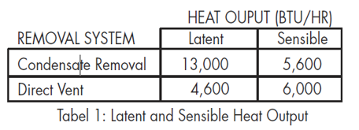
Based on the OEM Table above what is the total load if the system does not have a direct vent?

13,000 + 5,600 = 18,600 Btuh

Given a food service equipment internal load of 89,618: what would the load be with a diversity factor of 0.66?

Total Internal Load = 0.66 × 89,618 = 59148 Btuh

Field Notes:

A kitchen was always hot and humid. The technician was called to check the HVAC system. While there, the technician noticed the exhaust venting over the dishwasher didn’t seem to be removing moisture and heat intermittently. After making sure the HVAC system was operating as designed, the technician checked the exhaust fan for the dishwasher vent and found the single-phase exhaust motor was running at high amps (at the correct voltage) and was going off on an internal overload intermittently. Thus, it was determined the motor was undersized. The ¾ HP motor was replace with a 1 HP motor and the hood stayed on. This resolved the cooling issue in the kitchen. Note: the calculated heat load increase from the vented to the unvented dishwasher example shown in this lesson could be calculated as 18,600 – 10,600 = 8,000 Btuh, and all of that increase is in latent heat.

