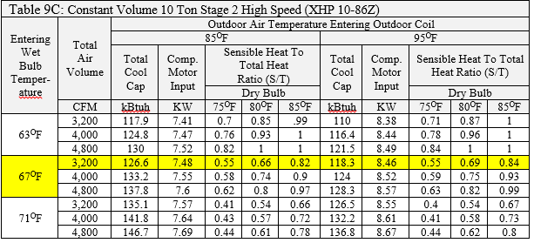
Using the chart above interpolate for the KBtuh value for an entering wet bulb temperature of 63^{O}F and 4,000 CFM at 90^{O}F

Using the chart above interpolate for the KBtuh value for an entering wet bulb temperature of 67^{O}F and 4,000 CFM at 87^{O}F

Using the chart above interpolate for the KBtuh value for an entering wet bulb temperature of 67^{O}F and 4,800 CFM at 92^{O}F

Field Notes:
Two common mistakes found in the field are equipment that was sized based on the rated load values not the expanded values and equipment installed, started up and left running right like it came out of the box.
Only technician’s that can look at the expanded data, and then set up a system to run at the correct CFM can make a system run as designed.
Note: Sometimes the only way it can meet the heating and cooling load requirements.

