Using the 20ft by 8ft window measurements, what is the square footage of the window?

Based on Figure A2 on page 67, what is the square footage of the roof’s surface (also the Ceiling total square footage)?

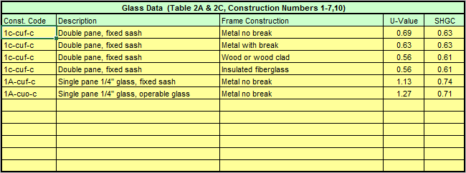

Using the glass data table above, in the Guide & Workbook, what are the table values for the solar heat gain coefficient and U-Value for a Single Pain ¼” fixed sash window?

What are the table values for the solar heat gain coefficient and U-Value for a Double Pain fixed sash Wood or wood clad window.

Which of the two windows above will allow less heat to transfer through it?

Calculate the front door’s square footage using the information in Figure A1 on page 66 in the Guide & workbook.

Field Notes:

In the summer the southwest side of building always ran hot in the afternoon, and the southeast side ran warm in the mornings. Over a ten year period, many technician’s had been called, and in turn had visited the building to no avail. The report always came back the same, the HVAC is working properly and you already have the maximum airflow available to those areas. Finally one technician asked to see the building’s plans. The technician discovered that to cut corners the builder had substituted a double pane aluminum window with no break, for the specified triple pane fiberglass frame windows. Thus, the HVAC system was not sized and installed for the as built building conditions, and could not meet the added load requirements. The final result was a reflective film was added to the windows on the south side of the building and the system began keeping the occupants comfortable in the summer for the first time in a decade.

