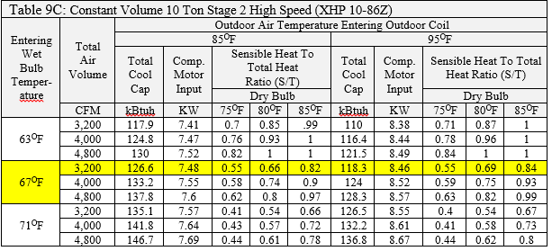
Using the chart above interpolate for the KBtuh value for an entering wet bulb temperature of 63^{O}F and 4,000 CFM at 90^{O}F

Easy Interpolation because it is at the midpoint between 85^{O}F and 95 ^{O}F. Thus the two values can be added and divided by 2.

(124.8 + 116.4) ÷ 2 = 120.6 kBtuh

Using the chart above interpolate for the KBtuh value for an entering wet bulb temperature of 67^{O}F and 4,000 CFM at 87^{O}F

Step 1: Temperature Total Difference: 95^{O}F - 85 ^{O}F = 10
Step 2: Temperature Ratio Factor: 95 – 87 = 8
Step 3: Temperature Ratio: 8 ÷ 10 = 0.8
Step 4: kBtuh total Difference: 133.2 – 124 = 9.2
Step 5: Temperature Ratio × kBtuh Total = 0.8× 9.2 = 7.36
Step 6: 124 + 7.36 = 131.36 kBtuh

Using the chart above interpolate for the KBtuh value for an entering wet bulb temperature of 67^{O}F and 4,800 CFM at 92^{O}F

Step 1: Temperature Total Difference: 95^{O}F - 85 ^{O}F = 10
Step 2: Temperature Ratio Factor: 95 – 92 = 3
Step 3: Temperature Ratio: 3 ÷ 10 = 0.3
Step 4: kBtuh total Difference: 137.8 – 128.3 = 9.5
Step 5: Temperature Ratio × kBtuh Total = 0.3 × 9.5 = 2.85
Step 6: 128.3 + 2.85 = 131.15 kBtuh

Field Notes:
Two common mistakes found in the field are equipment that was sized based on the rated load values not the expanded values and equipment installed, started up and left running right like it came out of the box.
Only technician’s that can look at the expanded data, and then set up a system to run at the correct CFM can make a system run as designed.
Note: Sometimes the only way it can meet the heating and cooling load requirements.

